Works available by Kerry Souter
'A Kiss of the Sea' Exhibition

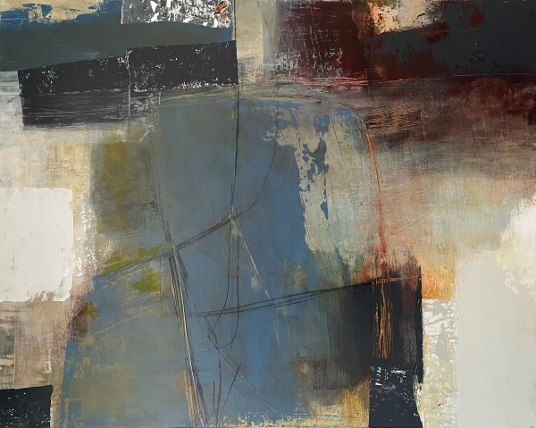 | Kerry Souter  Bold Reverie  Acrylic and mixed media on canvas  Framed Size: 83 x 103 cm | £ 1,750.00
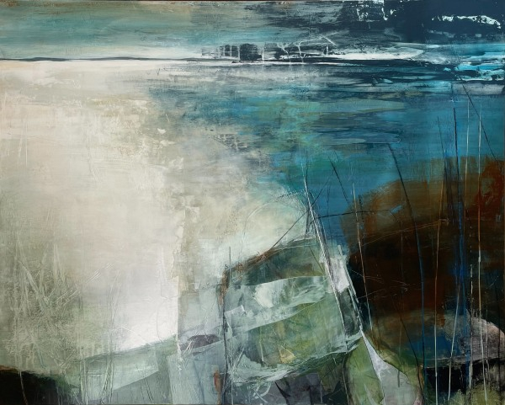 | Kerry Souter  Hebridean Reflections  Acrylic and mixed media on canvas  Framed Size: 83 x 103 cm | £ 1,750.00
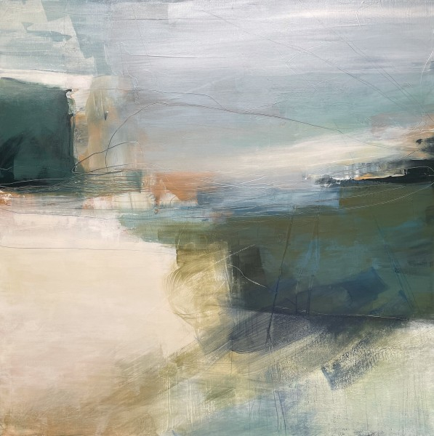 | Kerry Souter  Gentle Solace  Acrylic and mixed media on canvas  Framed Size: 83 x 83 cm | £ 1,495.00
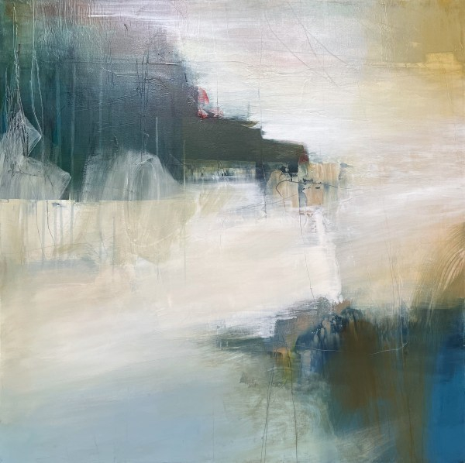 | Kerry Souter  Reflect and Rise  Acrylic and mixed media on canvas  Framed Size: 83 x 83 cm | £ 1,495.00
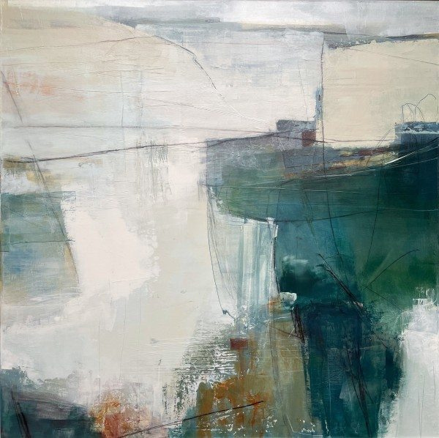 | Kerry Souter  Deep Breaths  Acrylic and mixed media on canvas  Framed Size: 93 x 93 cm | £ 1,695.00
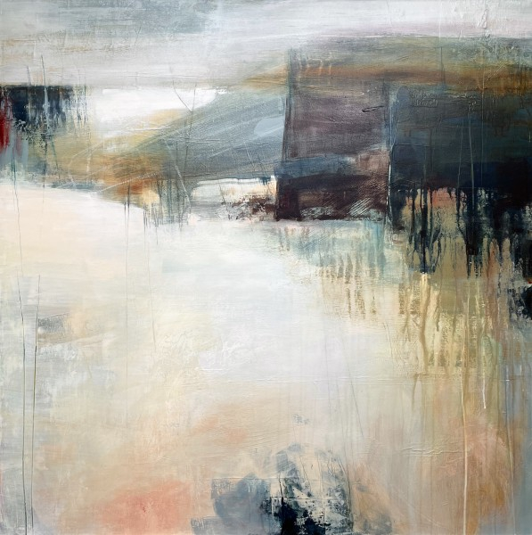 | Kerry Souter  Solitary Realm  Acrylic and mixed media on canvas  Framed Size: 93 x 93 cm | £ 1,695.00
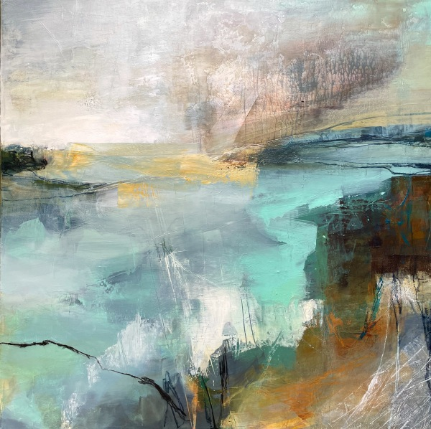 | Kerry Souter  I Think I Like When it Rains  Acrylic and mixed media on canvas  Framed Size: 93 x 93 cm | £ 1,695.00
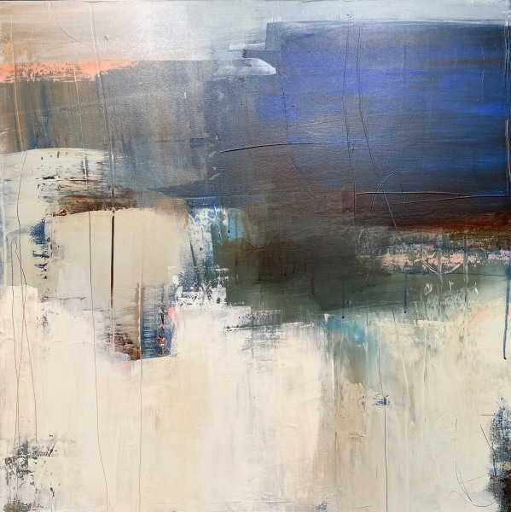 | Kerry Souter  Last Light  Acrylic and mixed media on canvas  Framed Size: 73 x 73 cm | £ 1,250.00
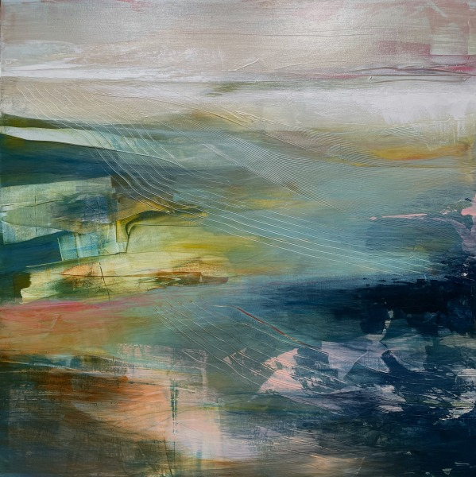 | Kerry Souter  She's a Rainbow  Acrylic and mixed media on canvas  Framed Size: 73 x 73 cm | £ 1,250.00
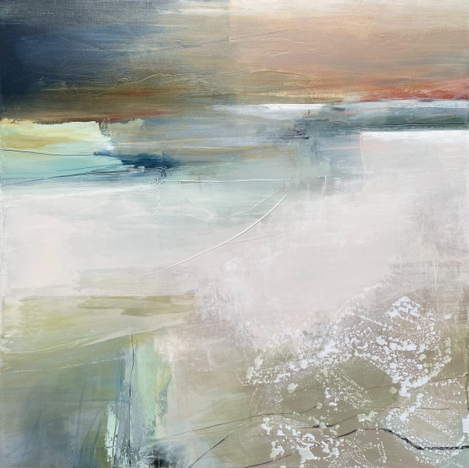 | Kerry Souter  Remember to Breathe  Acrylic and mixed media on canvas  Framed Size: 73 x 73 cm | £ 1,250.00
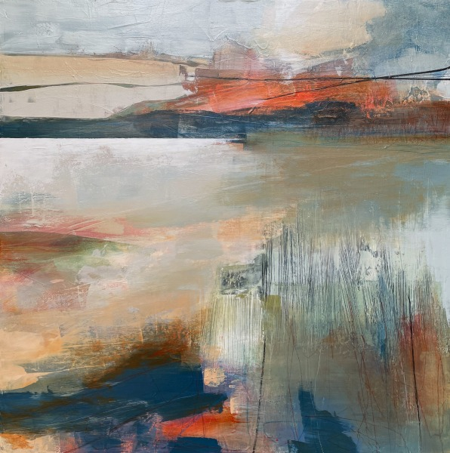 | Kerry Souter  Dancing in the Sky  Acrylic and mixed media on canvas  Framed Size: 73 x 73 cm | £ 1,250.00
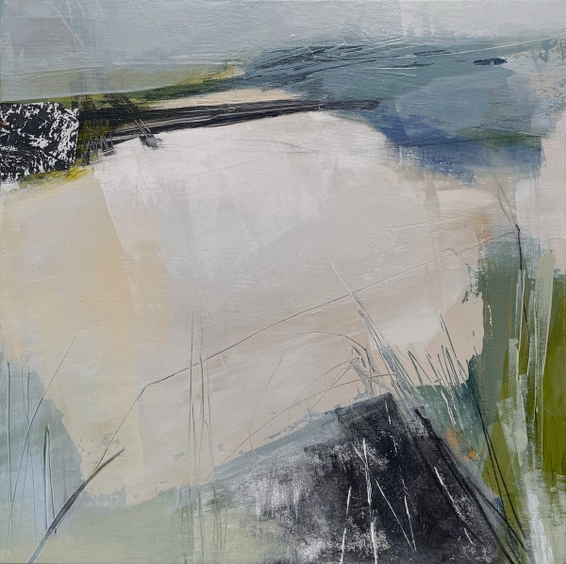 | Kerry Souter  Lay Low  Acrylic and mixed media on canvas  Framed Size: 53 x 53 cm | £ 750.00
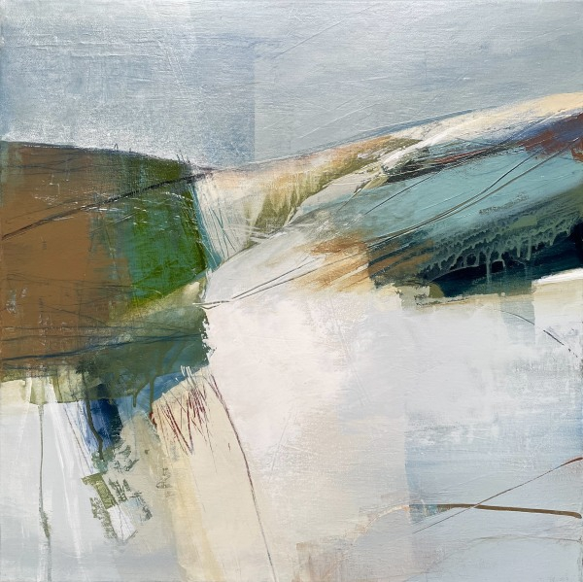 | Kerry Souter  Go Your Own Way  Acrylic and mixed media on canvas  Framed Size: 53 x 53 cm | £ 750.00
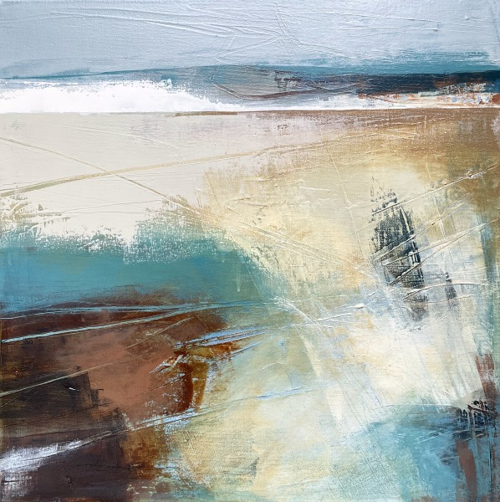 | Kerry Souter  Free Your Soul  Acrylic and mixed media on canvas  Framed Size: 53 x 53 cm | £ 750.00
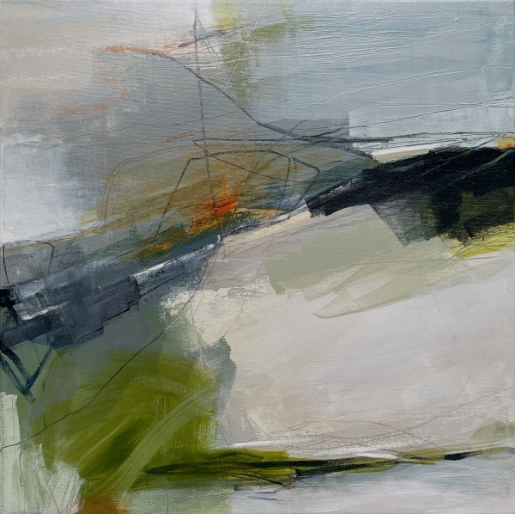 | Kerry Souter  One of These Mornings  Acrylic and mixed media on canvas  Framed Size: 53 x 53 cm | £ 750.00
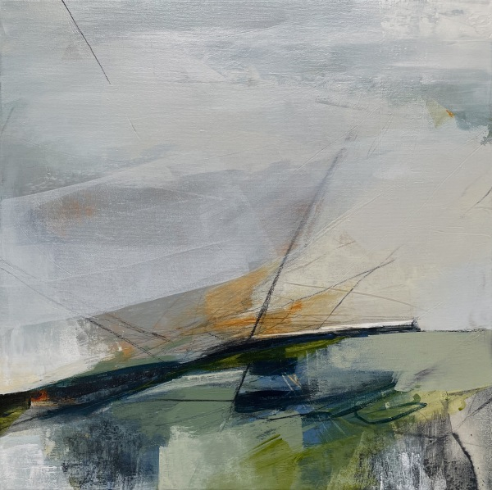 | Kerry Souter  Wind of Change  Acrylic and mixed media on canvas  Framed Size: 53 x 53 cm | £ 750.00
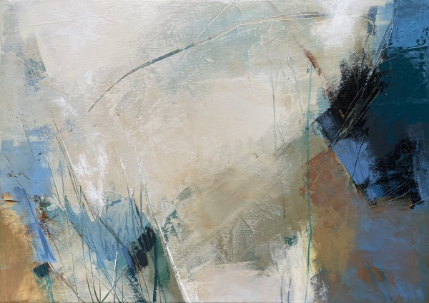 | Kerry Souter  It Was a Good Day  Acrylic and mixed media on canvas  Framed Size: 45 x 62 cm | £ 750.00
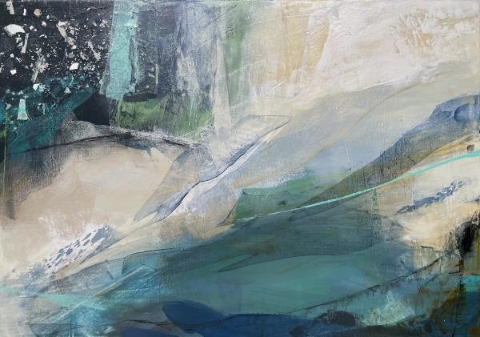 | Kerry Souter  Turquoise Waters  Acrylic and mixed media on canvas  Framed Size: 45 x 62 cm | £ 750.00
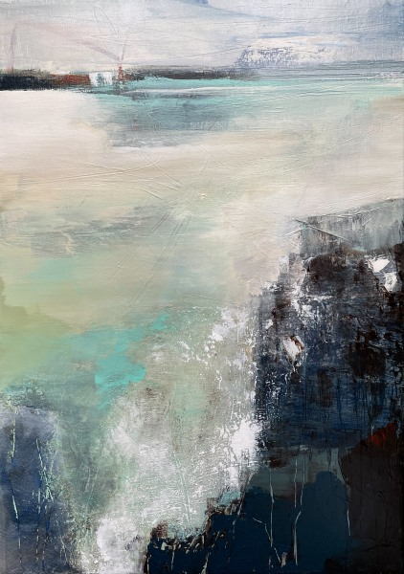 | Kerry Souter  Clear Mind  Acrylic and mixed media on canvas  Framed Size: 62 x 45 cm | £ 750.00
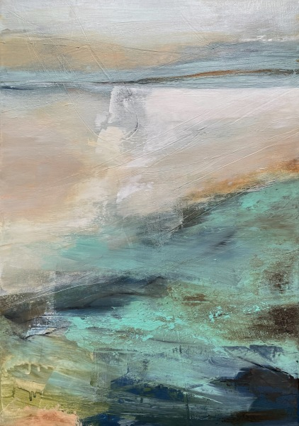 | Kerry Souter  Daydream  Acrylic and mixed media on canvas  Framed Size: 62 x 45 cm | £ 750.00
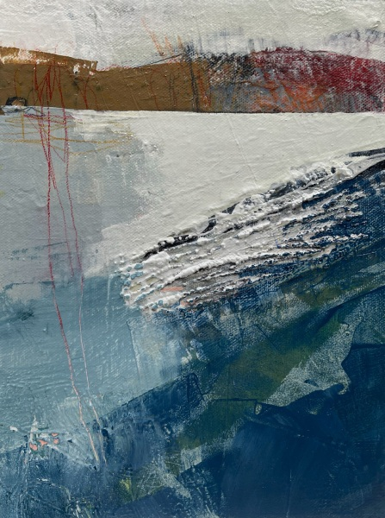 | Kerry Souter  We Know the Way  Acrylic and mixed media on board  Framed Size: 35 x 29 cm | £ 350.00
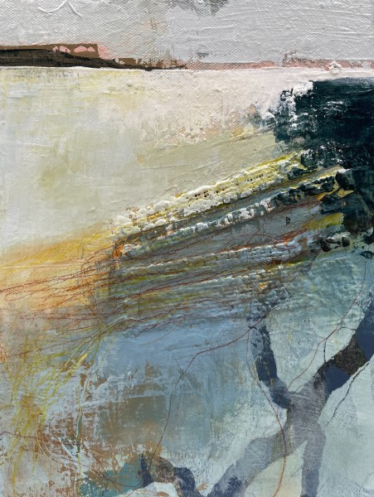 | Kerry Souter  Golden Hour  Acrylic and mixed media on board  Framed Size: 35 x 29 cm | £ 350.00
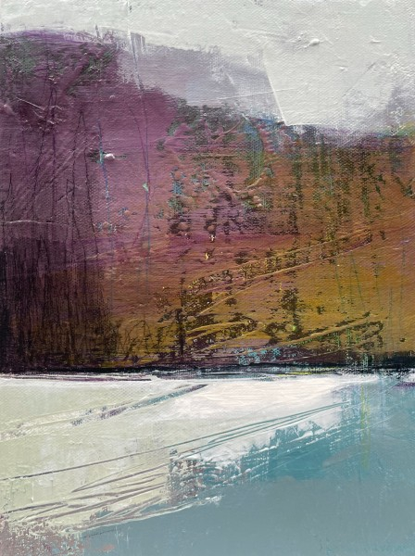 | Kerry Souter  Happy to be Here  Acrylic and mixed media on board  Framed Size: 35 x 29 cm | £ 350.00
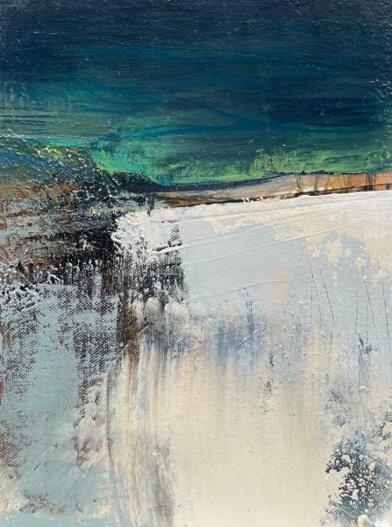 | Kerry Souter  Look at the Sky  Acrylic and mixed media on board  Framed Size: 35 x 29 cm | £ 350.00
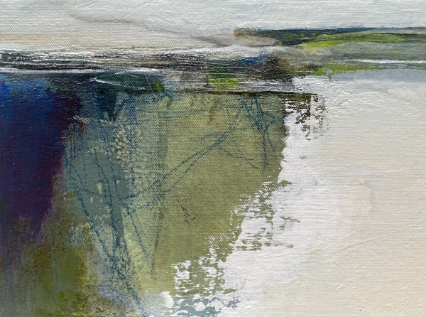 | Kerry Souter  Saltwater  Acrylic and mixed media on board  Framed Size: 29 x 35 cm | £ 350.00
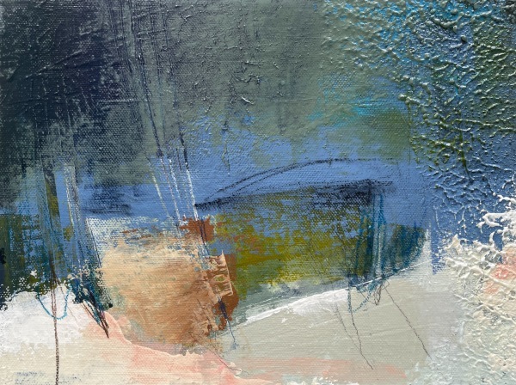 | Kerry Souter  Night Swimming  Acrylic and mixed media on board  Framed Size: 29 x 35 cm | £ 350.00
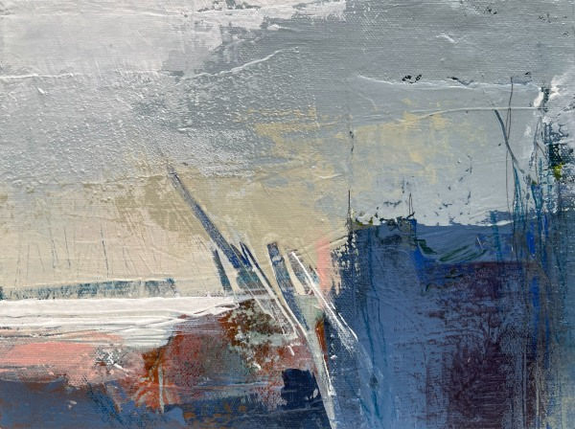 | Kerry Souter  So Far Away  Acrylic and mixed media on board  Framed Size: 29 x 35 cm | £ 350.00
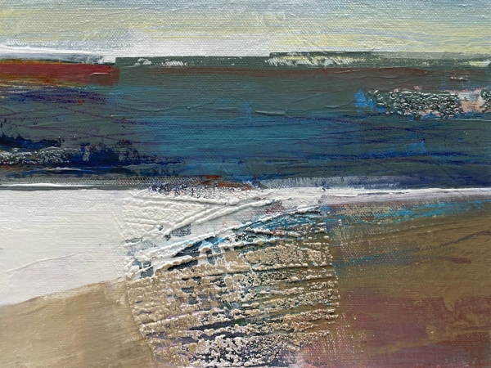 | Kerry Souter  Last of the Sunshine  Acrylic and mixed media on board  Framed Size: 29 x 35 cm | £ 350.00
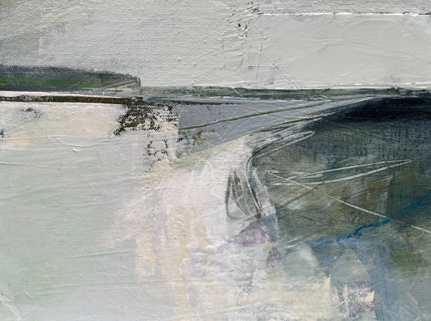 | Kerry Souter  Flowing Waters  Acrylic and mixed media on board  Framed Size: 29 x 35 cm | £ 350.00
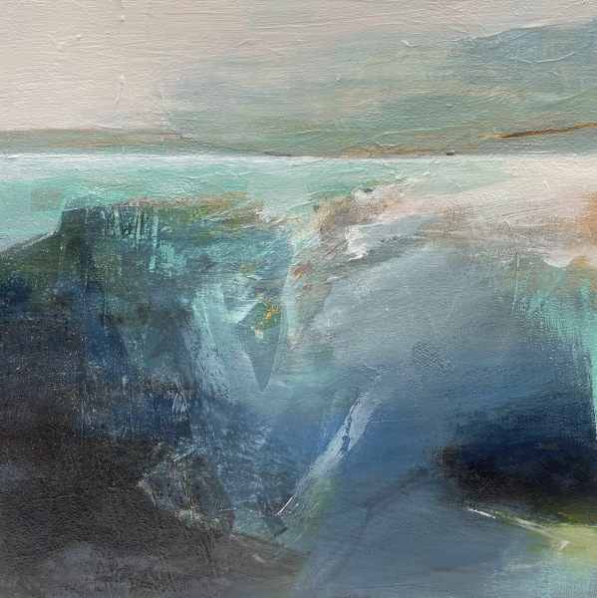 | Kerry Souter  Little Blue  Acrylic and mixed media on panel  Framed Size: 35 x 35 cm | £ 450.00
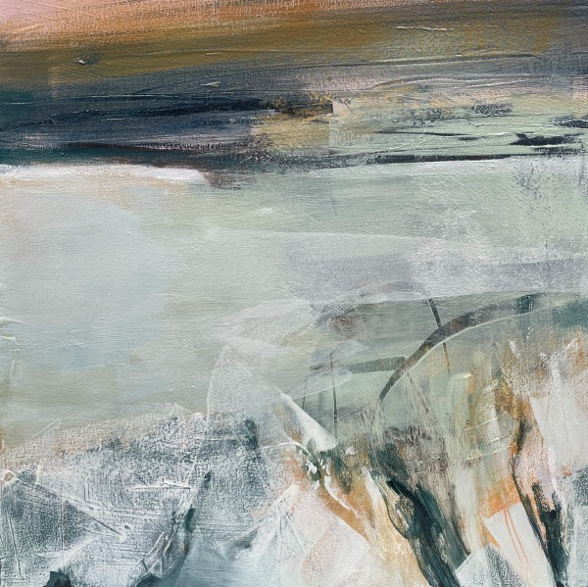 | Kerry Souter  Deep Rest in Solitude  Acrylic and mixed media on panel  Framed Size: 35 x 35 cm | £ 450.00
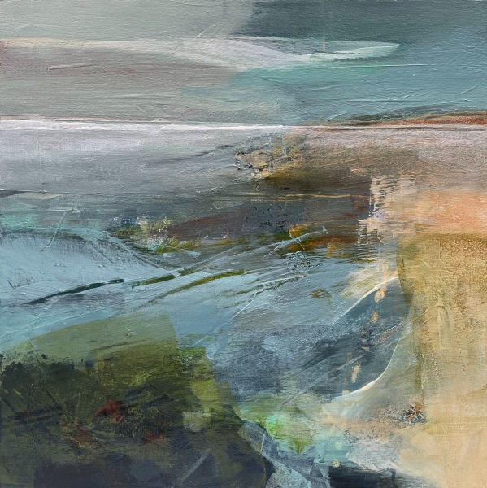 | Kerry Souter  Feel the Moment  Acrylic and mixed media on panel  Framed Size: 35 x 35 cm | £ 450.00
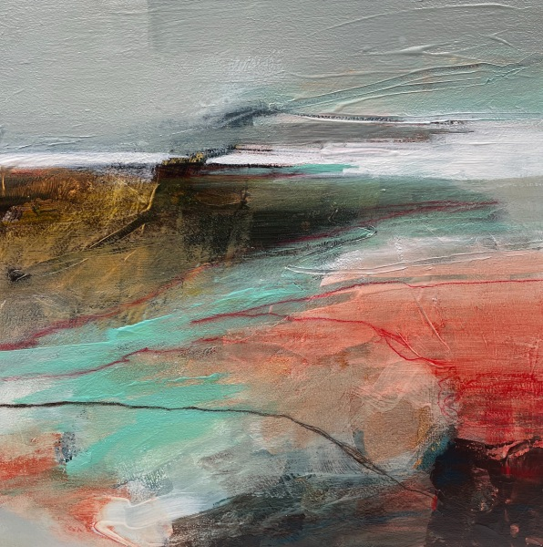 | Kerry Souter  Pursuit of Happiness  Acrylic and mixed media on panel  Framed Size: 35 x 35 cm | £ 450.00
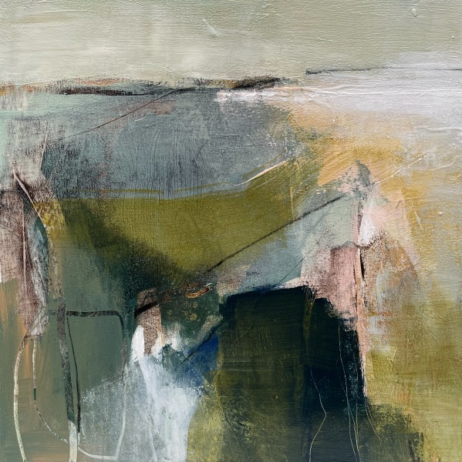 | Kerry Souter  Coastline Drift  Acrylic and mixed media on panel  Framed Size: 35 x 35 cm | £ 450.00
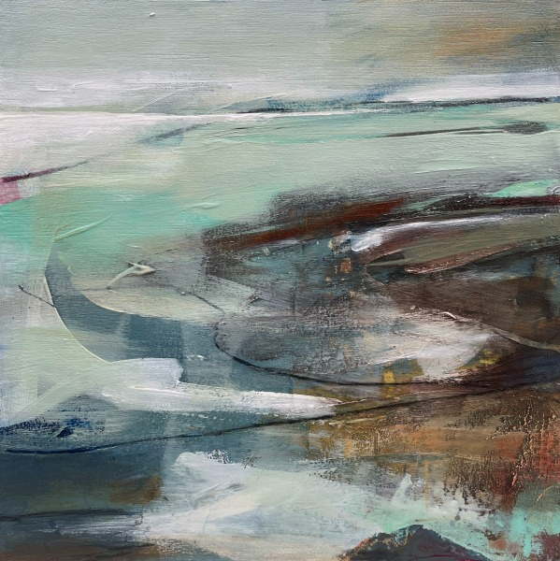 | Kerry Souter  Broken Coastline  Acrylic and mixed media on panel  Framed Size: 35 x 35 cm | £ 450.00
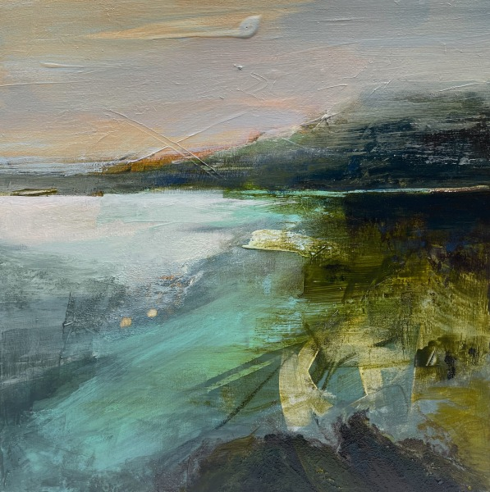 | Kerry Souter  Sundown  Acrylic and mixed media on panel  Framed Size: 35 x 35 cm | £ 450.00
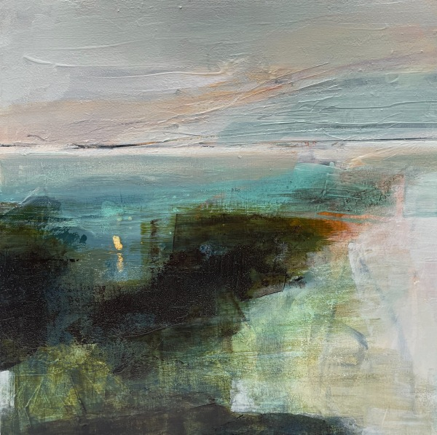 | Kerry Souter  Let Your Light Shine  Acrylic and mixed media on panel  Framed Size: 35 x 35 cm | £ 450.00
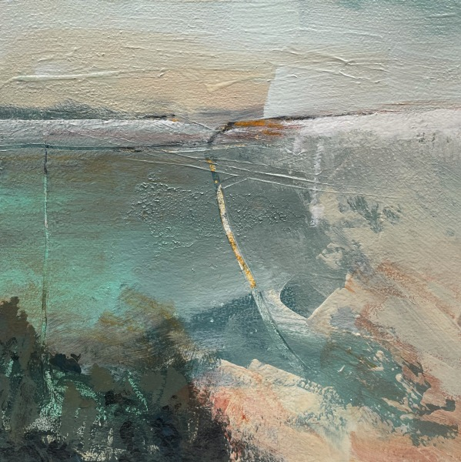 | Kerry Souter  Summer Nights  Acrylic and mixed media on panel  Framed Size: 32 x 32 cm | £ 350.00
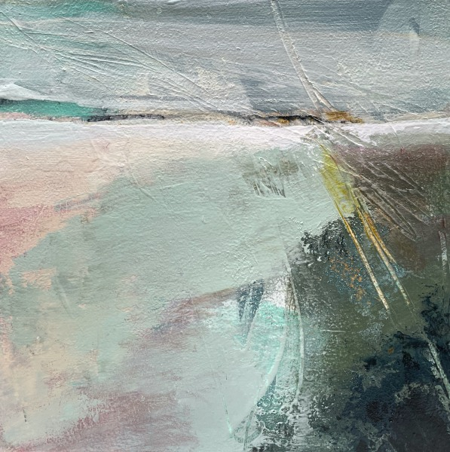 | Kerry Souter  Feels Like Summer  Acrylic and mixed media on panel  Framed Size: 32 x 32 cm | £ 350.00
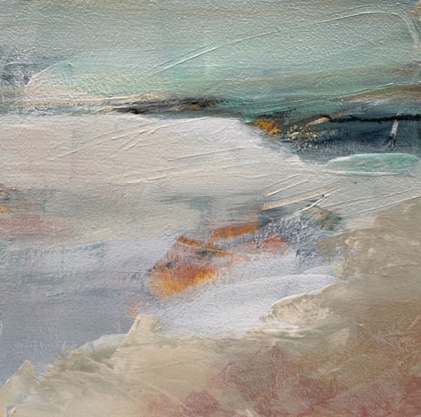 | Kerry Souter  Essence  Acrylic and mixed media on panel  Framed Size: 32 x 32 cm | £ 350.00
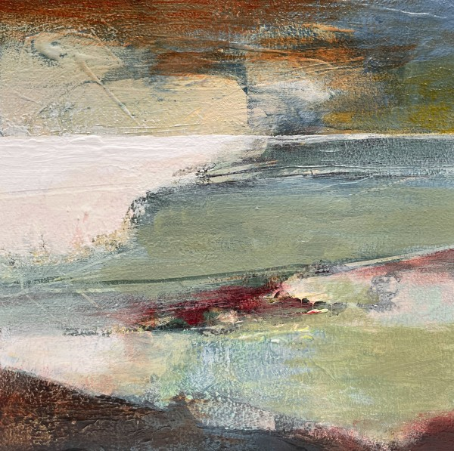 | Kerry Souter  Pure Shores  Acrylic and mixed media on panel  Framed Size: 32 x 32 cm | £ 350.00
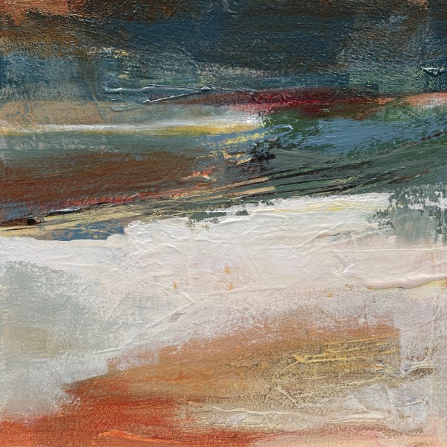 | Kerry Souter  Feel the Pressure  Acrylic and mixed media on panel  Framed Size: 32 x 32 cm | £ 350.00
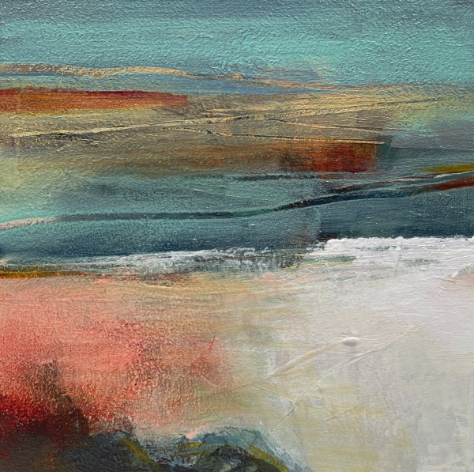 | Kerry Souter  Happy Place  Acrylic and mixed media on panel  Framed Size: 32 x 32 cm | £ 350.00
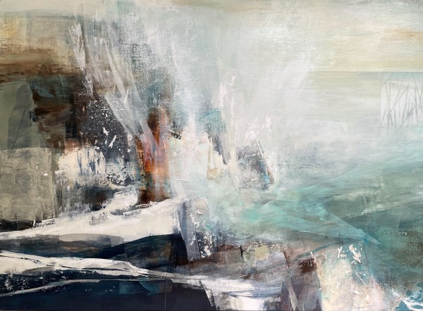 | Kerry Souter  Boundless  Acrylic and mixed media on canvas  Framed Size: 114 x 154 cm | £ 2,750.00

